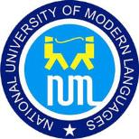
UNDERTAKING FORM

(40% Project Completion Certification)
Department of Computer Science
National University of Modern Languages, Multan Campus

Project Title: _________________________________________________________________________________________

_________________________________________________________________________________________________________

Supervisor Name: ______________________________________________________
Student Details:
Student Name | Roll Number | Signature
_________________ | _________________ | _________________
_________________ | _________________ | _________________
_________________ | _________________ | _________________
_________________ | _________________ | _________________

We, the undersigned students of the above-mentioned project, hereby declare that we have completed at least 40% of the project work as per the defined objectives and deliverables.
We affirm that we will continue working diligently on the remaining milestones as per the project timeline.
Date: _______________
Supervisor’s Signature: _____________________________
Date: _____________________________

